

**HUMAN COMPUTER INTERACTION**

**PROJECT PROPOSAL**

***PROJECT NAME:***

***SMARTLYCOOK APPLICATION***

***GROUP MEMBER:***

***SAMAN KHAN*** *(62514)*

***ZUNAIRA SULEMAN*** *(62658)*

***UROOBA AFTAB*** *(9013)*

**FEATURES**

1. Smart display
2. Touch control
3. Auto menu
4. Manual power level setting
5. Preheat
6. Built-in cooking setting
7. Quick Defrost
8. Child lockout
9. Auto/Manual setting
10. Quick Froze.

**TASK ANALYSIS**

**GOAL:** To provide easiness to our customer by merging two different appliance functionality.

**PRECONDITION:**

* User must have an account for login.
* User need to know id and password.
* User must know the serial number of their appliance.
* User have to know the pin code.
* User must have any kind of food which will be making in that appliance.
* User must know the temperature and time limit.
* User have to select which category we will going to choose.
* User can set the power level to 100 %, 70 %, 50 %, 30 % or 10 %, according to the desired rate of cooking and type of food. In the same way you can also adjust the power level for the purpose of grilling, pr-heating the oven and convection cooking.

**TASK:**

**Combining oven and microwave and making it one appliance**

**1.1 Category**

**1.1.1 Microwave**

**1.1.1.1 Set power**

1.1.1.1.1 Low

1.1.1.1.2 High

**1.1.1.2 Set Timer**

1.1.1.2.1 Up

1.1.1.2.2 Down

**1.1.2 Grill**

**1.1.2.1 Set convention and grill**

**1.1.2.1.1 Set Timer**

1.1.2.1.1.1 Up

1.1.2.1.1.2 Down

**1.1.3 Set Combination**

1.1.3.1 C1 microwave and convention

1.1.3.2 C2 microwave and grill

1.1.3.3 C3 microwave and grill(70% grill 30% microwave)

1.1.3.4 C4 microwave convention grill

**1.1.4 Baking**

**1.1.4.1 Preheat**

**1.1.4.1.1 Set Temperature**

1.1.4.1.1.1 High

1.1.4.1.1.2 low

1.1.5 Stop/Clear

1.1.6 Start

1.1.7 Bottom element heat

**1.1.9 Arrows**

1.1.9.1 Up

1.1.9.2 Down

**1.10 Stoves**

**1.10.1 Set Temperature according to food**

**1.10.1.1 Set Power**

1.10.1.1.1 High

1.10.1.1.2 Low

**1.11 Control Stove**

**1.12 Automatic Manual Setting**

1.12.1 On

1.12.2 Off

**1.13 Froze**

**1.13.1 Set Temperature**

1.13.1.1 High

1.13.1.2 low

**1.14 Defrost**

**1.14.1 Set Temperature**

1.14.1.1 High

1.14.1.2 low

**1.15 Child Lock**

1.15.1 Face Recognition

1.15.2 Pin code

**1.16 History**

**USECASE DIAGRAM**

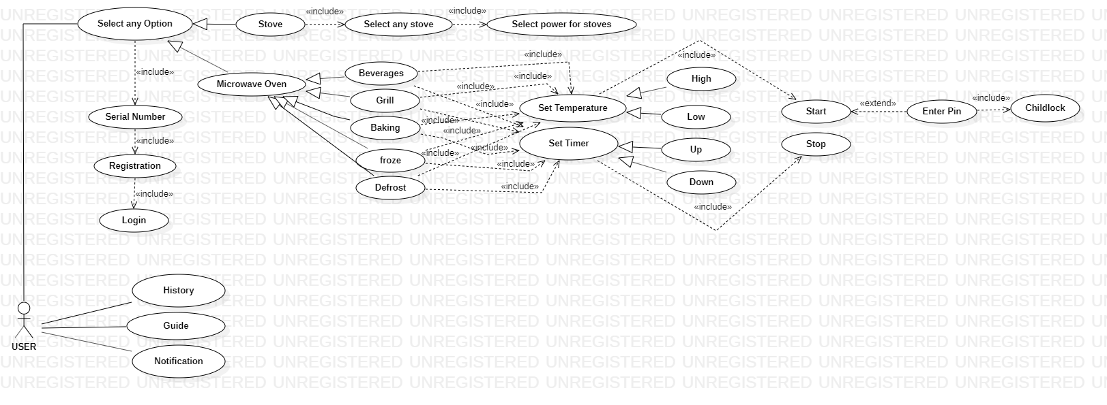

**STOARYBOARD**

THEY MAKE LUNCH

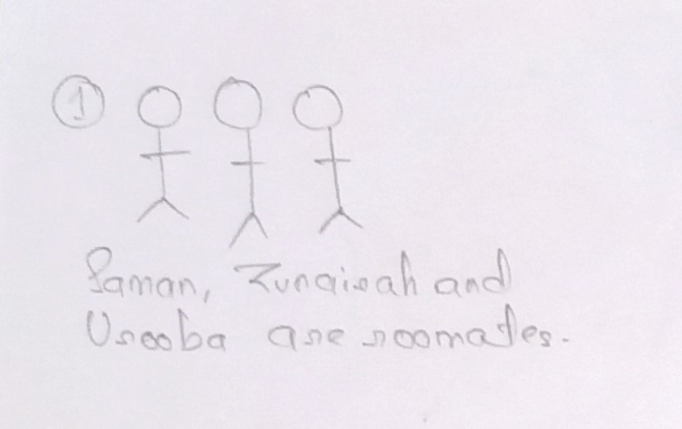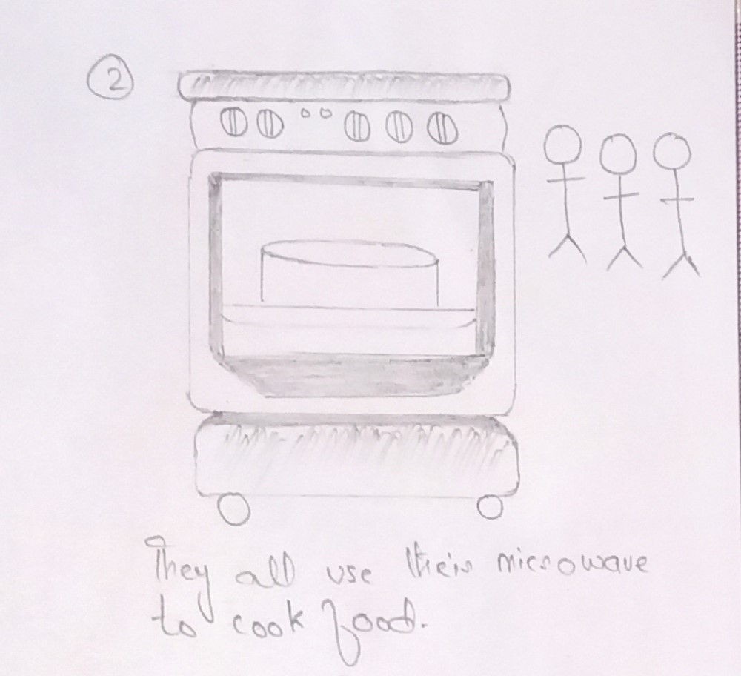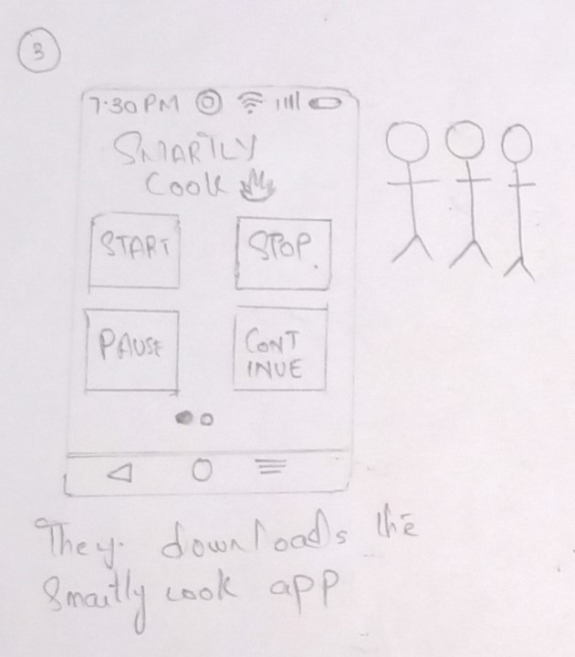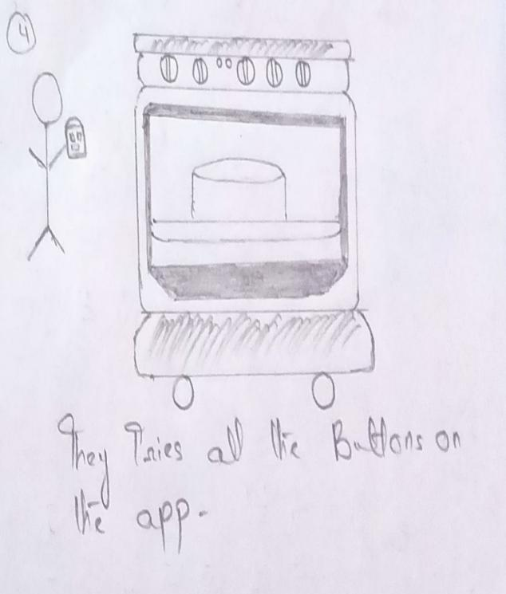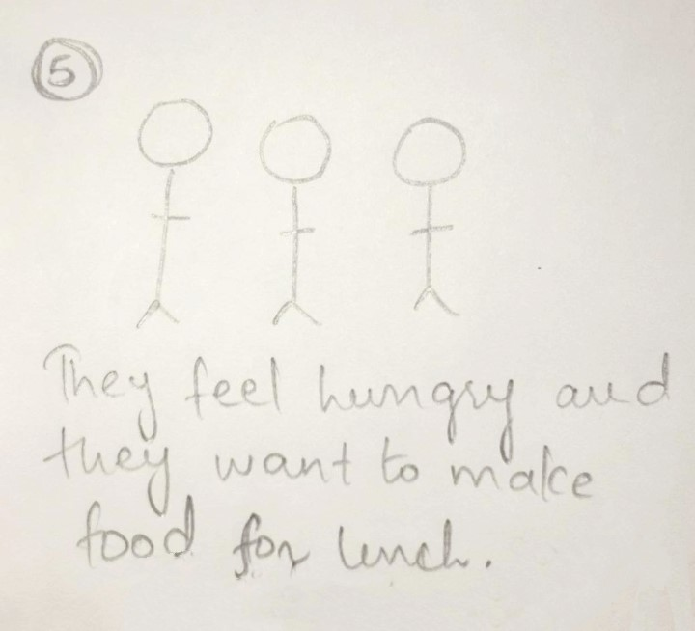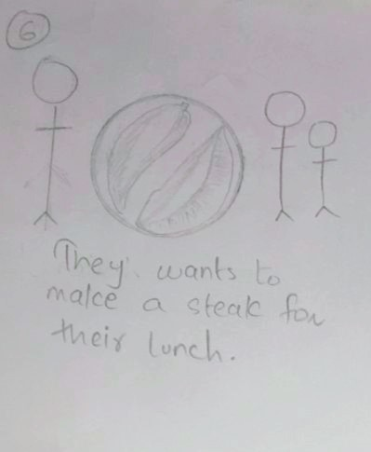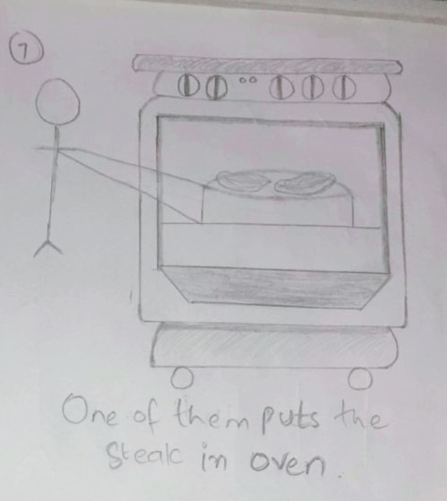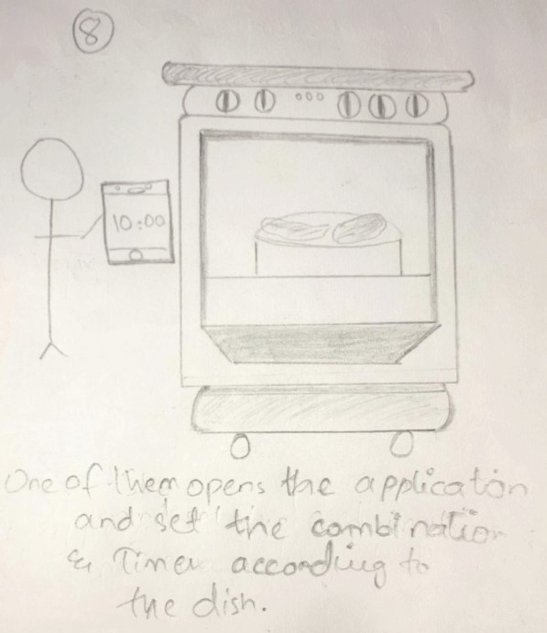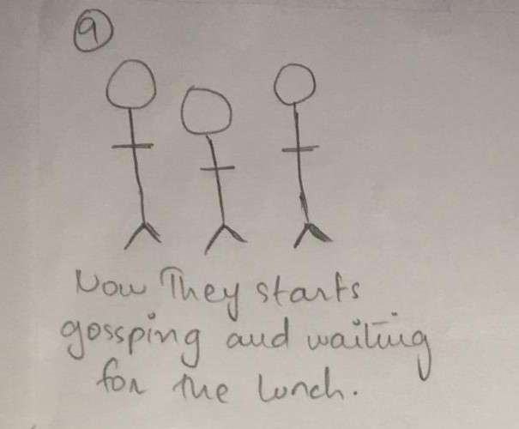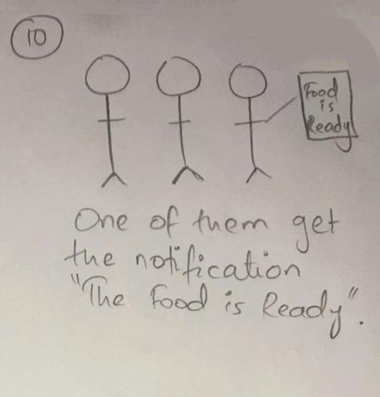

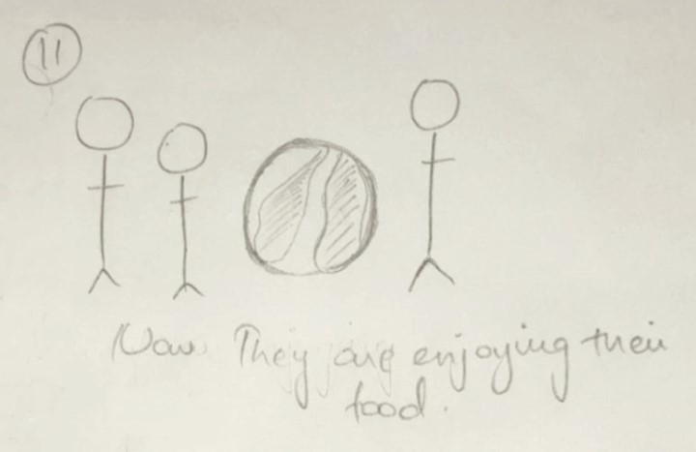

**PROTOTYPE**

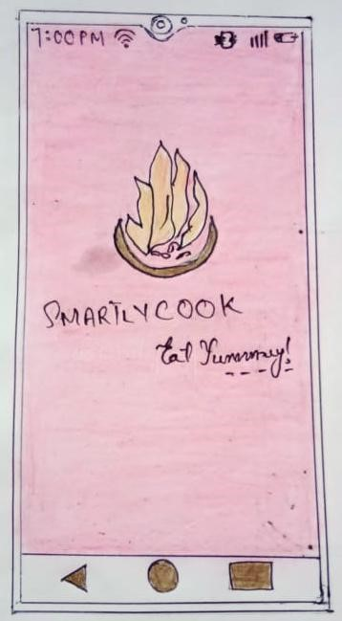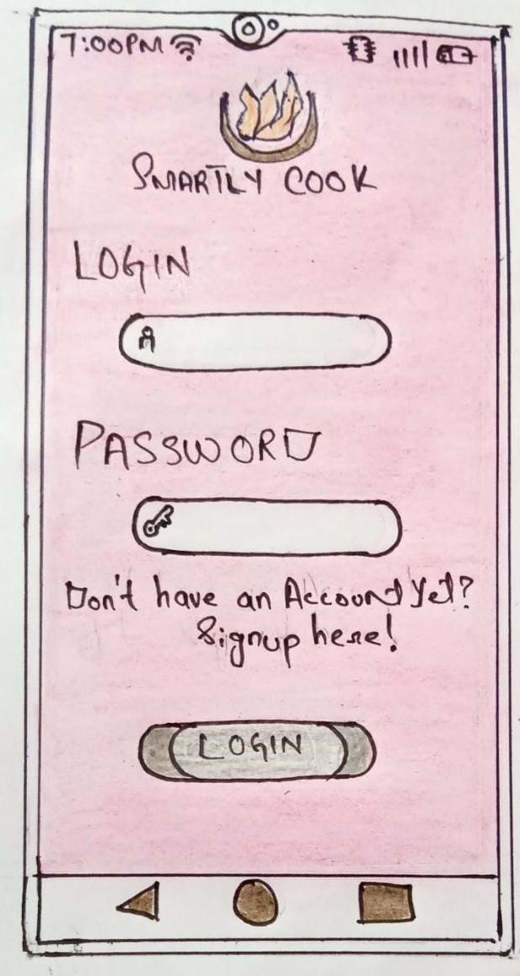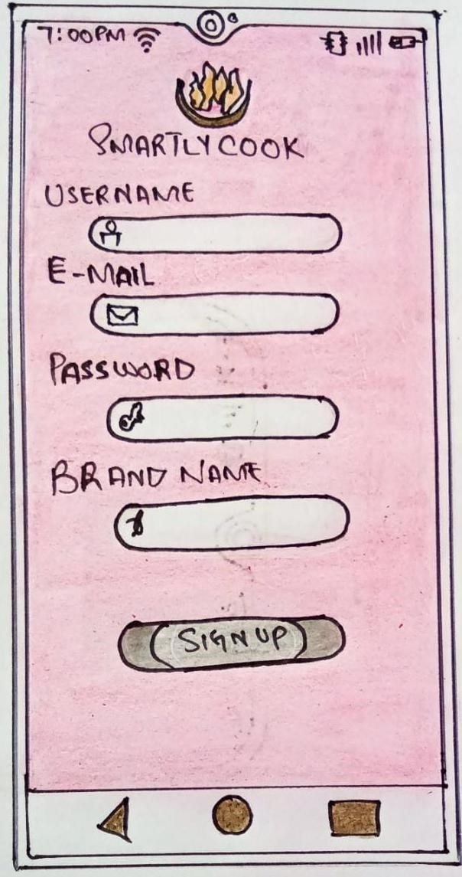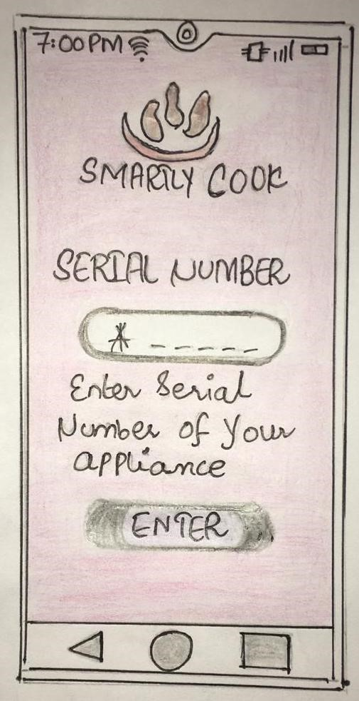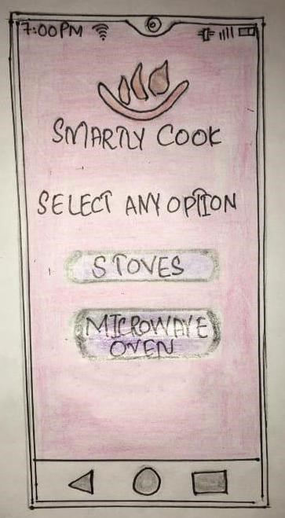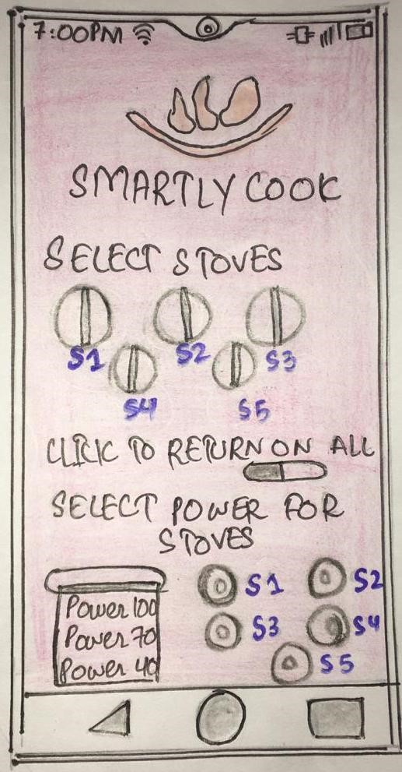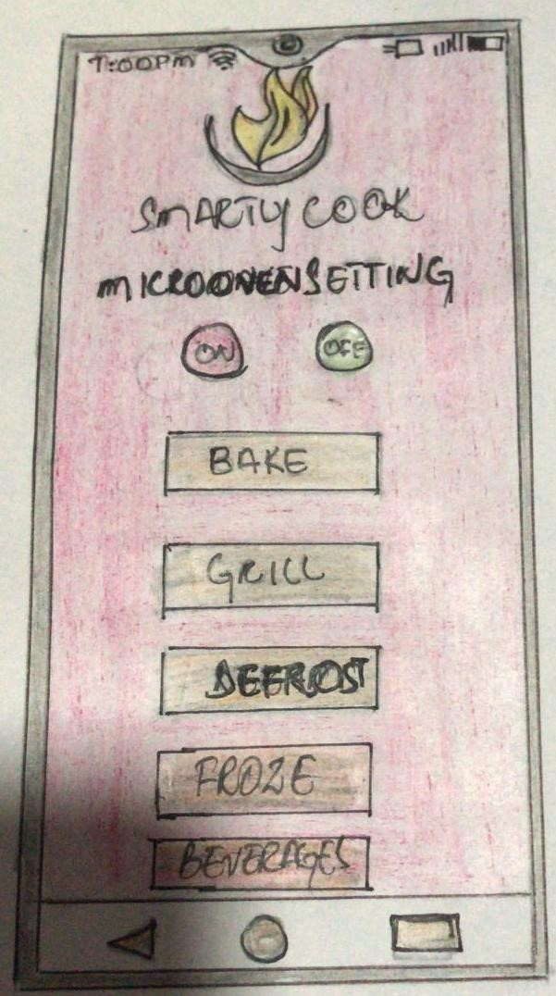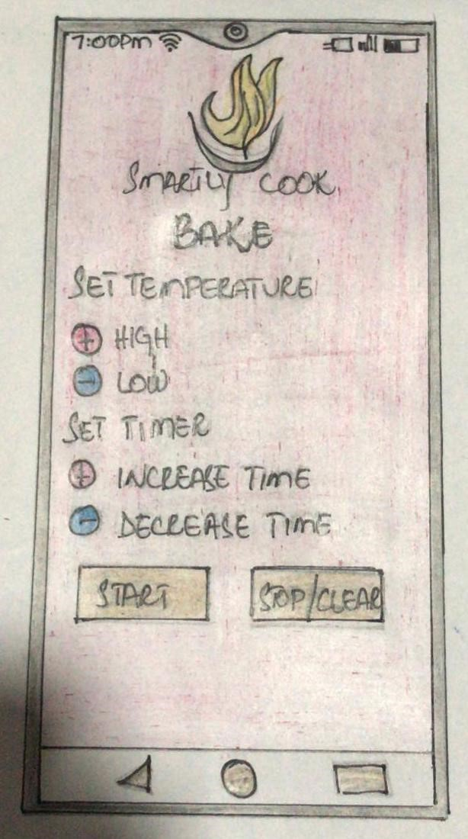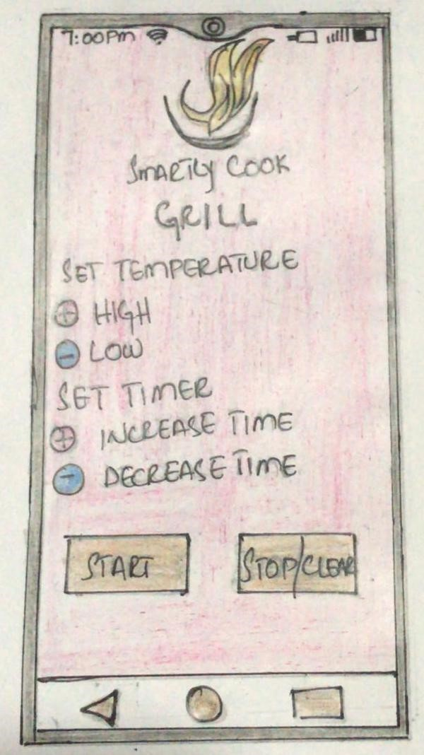

9

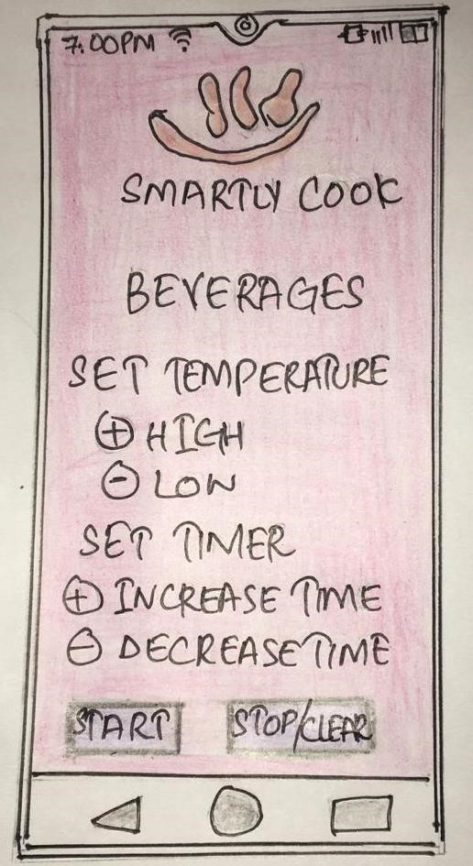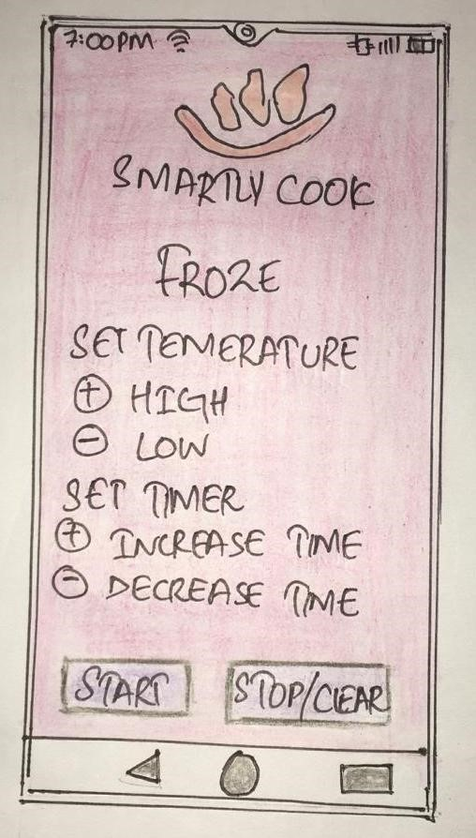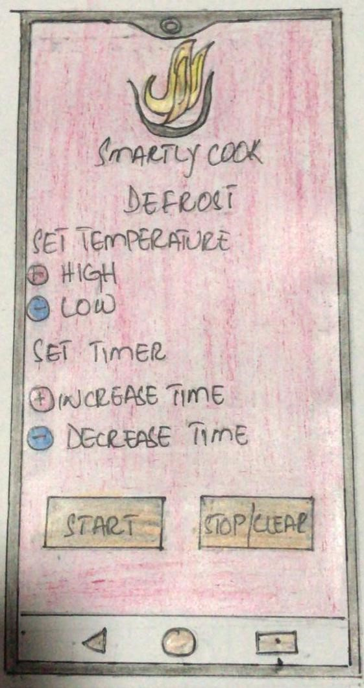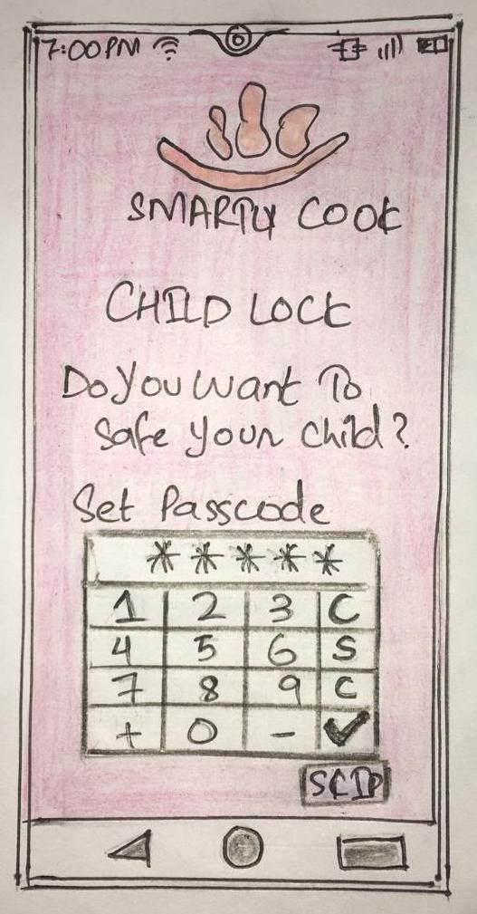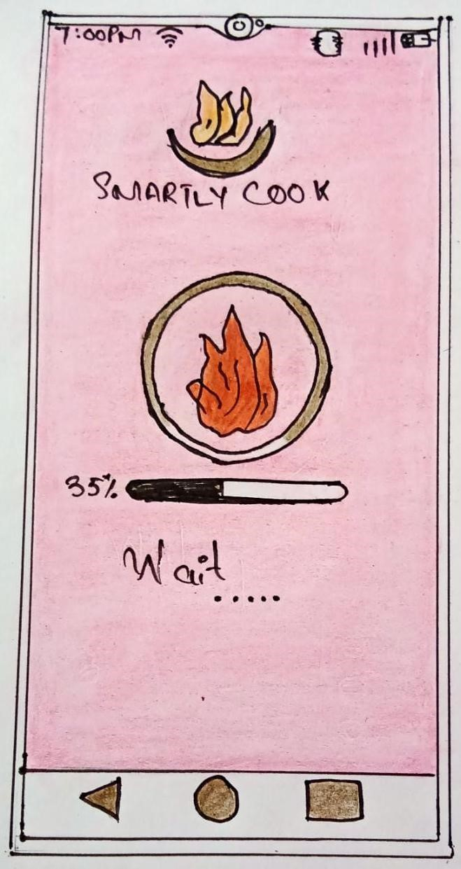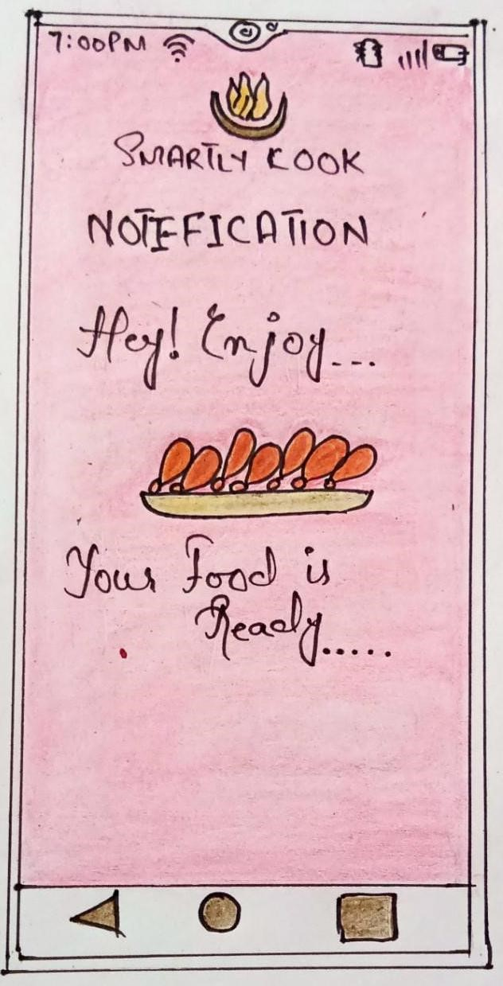

**HISTORY SCREEN**

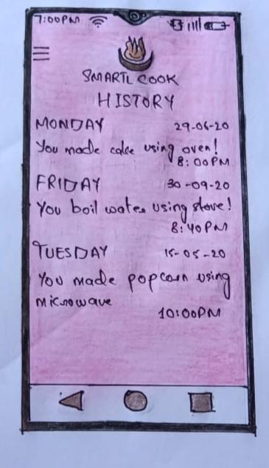

16

**GUID SCREEN**

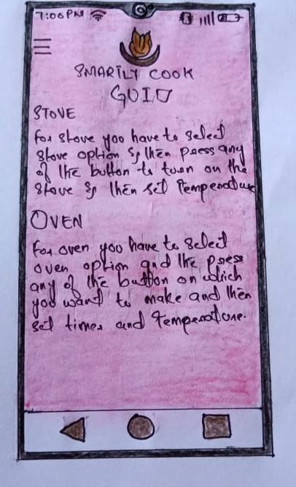

17

VIDEO LINK

**https://drive.google.com/file/d/1zHPHYIh3dPXC6MXGCHEp9caz64wJWQB8/view?usp=sharing**

**PERSONAS**



**BIOGRAPHY:**

This is my partner Saman.

She is 21 years old.

She is a student

She is doing Software Engineering from PAK-KIET. She lives in Karachi.

**HOBBY:**

She is a food lover . She loves to try different foods . She loves to visit different resturants in order to taste different kinds of food. She also loves to travel new places. She is such an intelligent person. She spents most of her in doing study and in her free time she loves to watch movies.

**INTEREST:**

She has insterest in doing programming , explore multiple language regarding her field. She has also her real interest in android development , web designing , and many more. She loves to make mobile application and she explores and use many software related android application like Wappler , adobe XD and many more.

**GOAL:**

She wants to make an application which provide ease to the people to use their oven. Her goal is to create a 3in1 application in which stoves , microwave and oven all get operated in one application on just one-click.

**PROBLEMS:**

She face so many problems in her application. First it doesn’t look convinent for the user. Secondly the goal to make an application is the application should be user-friendly but her application isn’t look that user-friendly as user feels good and comfortable while using the app. She also face problems in her functionality while using her app , it doesn’t work properly and also her functionality is not easy to use.

**IMPROVEMENT:**

She get overcome from her problems by testifying and doing research related her problems. She takes feedback of different user in order get problems which user is facing and by interacting them. She started doing working on her application in order to make it more convenient for her users and make them feel good while using the application she makes different prototypes in order to change her UI and she also works on her functionality that why they are not working perfectly and by adding new functionalities and use other software in which she can add more understandable functionalities for her user and also solve the problem of her functionalities.

**FEEDBACK:**

From After few days , she complete her application by solving her problems and after that the application looks quite user-friendly , easy to use and attractive.

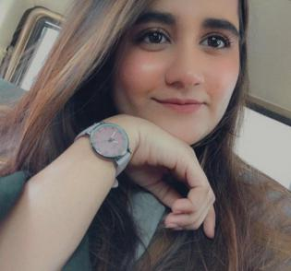

**BIOGRAPHY:**

This is Zunairah

She is 20 years old.

She is student

She is doing software engneering. She is in semster 5 She lives in Karachi.

**HOBBY:**

Her day starts with study and end on study, she love to study all the time, she has potention to do some creative things according to her field, she also love to play video games before bed time.

**INTEREST:**

she love her field so much her intrest is to make different types of mobile application which is also convenient to the users, she also use adobe xd,wappler and andriod studio for the prototype and functionality of the applications.

**GOAL:**

Her goal is to make a good application for microwave-oven to make cooking easy for the house wives and those who loves cooking.

**PROBLEM:**

When she start her project she face the problem which type of functionality should be added on the application which is useful and as well as simple so new user can easily use those funtions and the other problem was which theme has to choose to make the application attractive for the user.

**IMPROVMENT:**

She overcome her problem by interaction with multiple users, and she also reaserch according to that functionality and then try it on her own so she get to know which functionality work on which purpose and which functionality is difficult to use and make her confuse, so after that reaserch she has added that functionalities in a very easy form on mobile application so the new user and the daily user both can use this application easily.

**FEEDBACK:**

After completion of application, she get good response form the users.



**BIOGRAPHY :**

She is UROOBA AFTAB she is 21 years old.

She lives in KARACHI ,PAKISTAN She is doing BSCS from PAFKIET

**HOBBY:**

She is pet lover, especially she loves cats ..she has two cats in her house and she loves to take care of them and after that she do her studies and help their fellows in studies..she loves to help other peoples..and in her free time she watches seaons on Netflix to make her mind relaxed

**INTEREST:**

Her intrest is to make andrioid applications and she always make such convenient applications for the user to make her life easy and simple ..she always make amazing user inetface for the application to look good ..

**GOAL :**

She has a goal to make a 2 in 1 application of microwave and oven both User can easily use all the features of microwave and oven in one application ..

**PROBLEMS:**

She faced so many problems in this application firstly she can’t choose the correct platform..After that she faced difficuilties on functionality how can she make convenient app to make every user can easily perform their task on it ..

Then she wants to make option for child lock to safe childs she faced a problem how to make it easily ..

**IMPROVEMENT:**

After facing so many difficuilties then she overcome their problem firstly she choose the best software (andrioid application) to make her application on it ..then she make rough paper prototype how she manage all the pages and buttons and all the info about microwave and oven ..after prototype she implement all the features on software and for the child lock problem she made easy option for the user to set a password for the children .

**FEEDBACK:**

After 10 days she completes her application successfully with attractive interface .she gives access to everyone to use this application and make their life easier and after few days she receives a amazing response from everyone



**BIOGRAPHY :**

She is ZARAFSHAN KHAN She is 30 YEARS OLD..

She is housewife.

She has two kids .

Her husband is Accountant

She lives in Lahore ,PAKISTAN

**HOBBY**

She likes to travel and to read but her favourite hobby is cooking..she loves to cook food for herself and for her family .she has a youtube channel for cooking she makes a amazing food recipe video and posting on her channel….

**INTREST:**

Her intrest is to learn some new dishes daily and she wants to learn cooking by professionaly and wants to make a certified chef…

**GOAL :**

After some days, someone suggest her to use this microwave oven application which has all the functionalities of micro and oven as well as stoves … now her goal is to download this application and make delicious food for her family by using this application

**PROBLEMS:**

After downloading this applications she faced a lot of problems by using this application. The first thing is that she has to register her self before using this application which make her annoy because there is no option to direct logging just like by connecting gmail account user can login ,but there is no option for the user .Secondly, she confused about the serial number how can she find the number from her device..

**IMPROVEMENT:**

After using this application she wants to add option to login/register using gmail account and the second enhancement she wants to do is that add some guide for the serial number .

**FEEDBACK:**

After few days ,she enjoying this application and recommend to her friends to use it and now they all are using this application …



**BIOGRAPHY:**

This is maha

Her nickname is mano

She is student

She is 17 years old

She is in class 12

Her field is commerce She lives in Islamabad Pakistan.

**HOBBY:**

She love drwaing and sketching, she also love pets as well as she also try to make unique food for her family and her self.

**INTEREST:**

She learn something new by watching Youtube tutorials, do blogging all day long and wanted to do something unique, she has an intrest to make unique and new dishes and try new flavours.

**GOAL:**

Just because she love to make new and unique food, she got an application microwave-oven which has all kind of funtionality of microwave and oven as well as stove. Now her goal is to make food by using this application.

**PROBLEM:**

When she start using application , firstly she get confused that how to use this application and the second thing she does’not like about this application is it’s ui which is not so attractive according to her opinnion.

**IMPROVEMENT:**

She wants to improve the ui of this application and add some guid that how to use this application.

**FEEDBACK:**

After using this application for few months, her feedback is so positive and she love to use this application, her life is became so easy just becasue of this application.



**BIOGRAPHY:**

This is Omar

He has done his BBA

He is 26 years old

He works at Brandkey Communications

He work as a Social Media Specialist at Brandkey Communications He lives in Karachi, Sindh, Pakistan.

**HOBBY:**

He is a fitness freak, his daily routine is that he do exerciw before going to office. He only eat healthy food items just to maintain his fitness and body. He also love to play football, badminton and cricket as well.

**INTEREST:**

He loves to travel different exotic places As he loves to travel, he also loves to make food at home that he taste during his time in those traveling days.

**GOAL:**

As he is fitness freak, he wants to make some grill fish, meat and boil veggis.

His colleague suggest him an application which is microwave-oven to make food easily by using mobile application, so now his goal is to try this application and make a good healthy meal for himself.

**PROBLEMS:**

When he start making meal for himself, he get confused by using stove option that which stove is working on which button and the second problem was that how to set temperature of stove becasue there is no proper guide for stove.

**IMPROVEMENT:**

He wants to add some guide for all the functionality of this application.

**FEEDBACK:**

After using this application, he has shown reliable confident in the Application and is very staisfy with it. Also he thanked his colleague to suggest him this application.

**PROJECT UI**

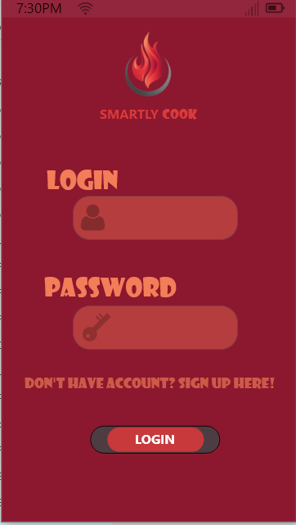

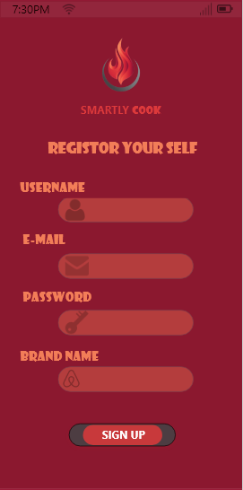

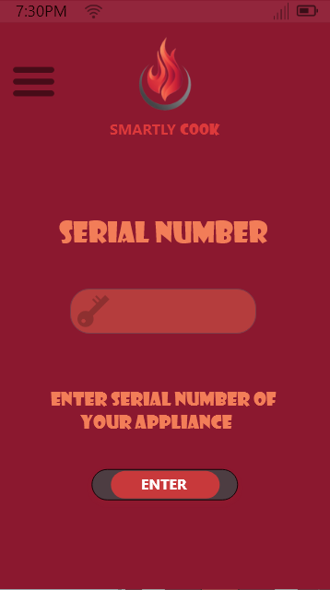

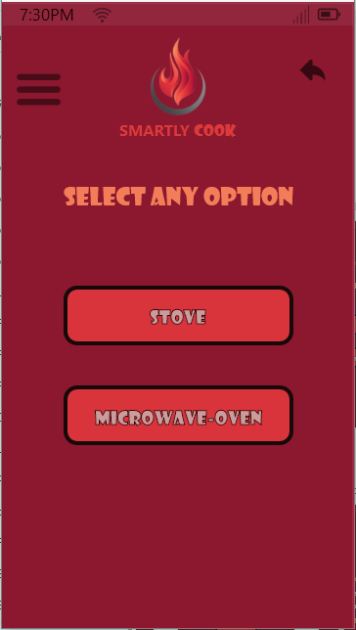

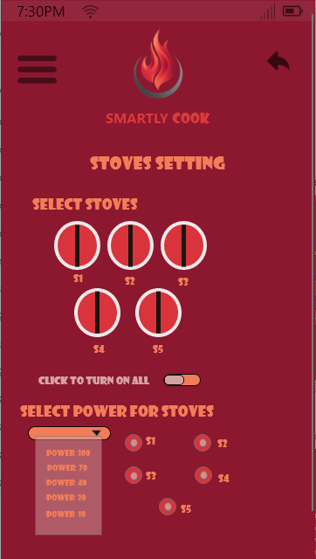

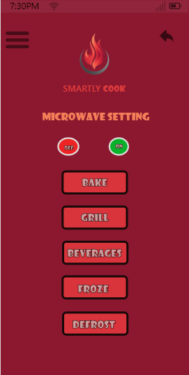

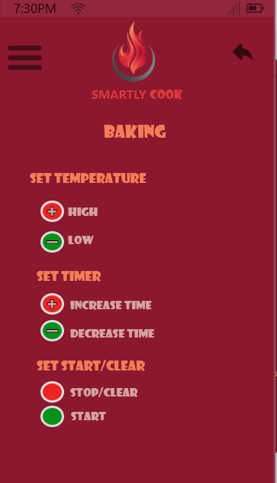

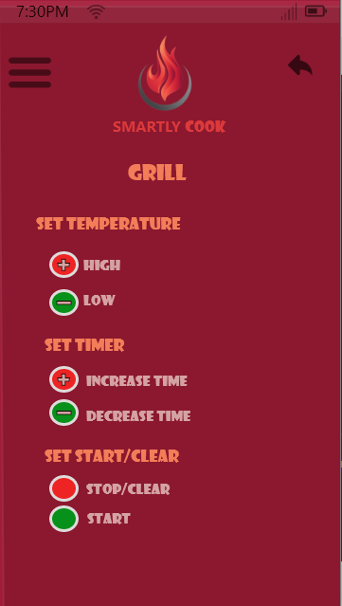

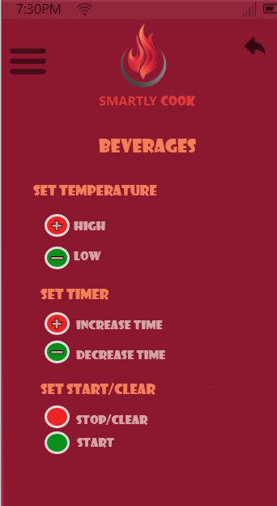

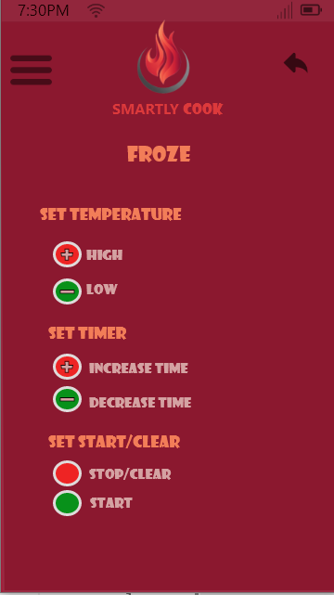

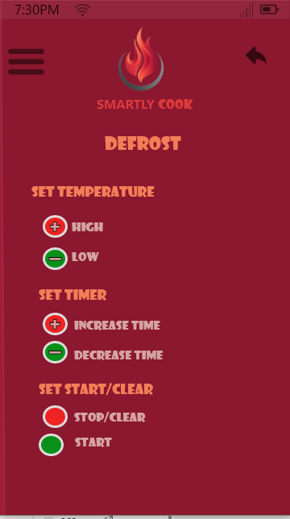

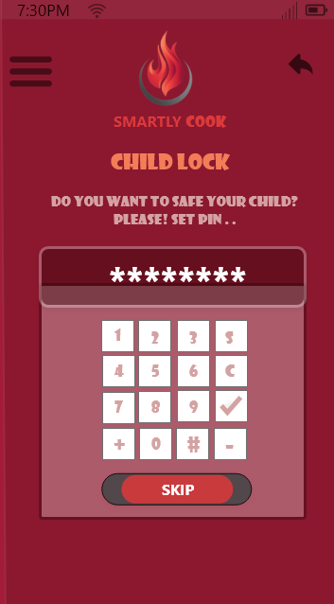

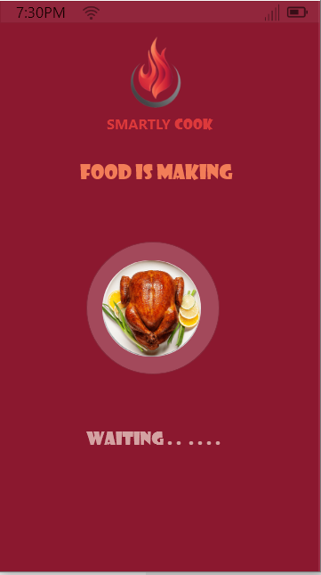

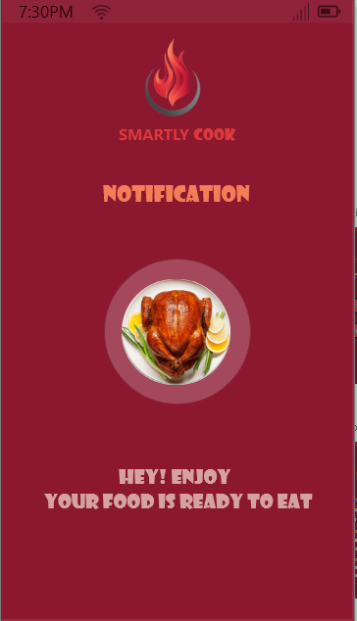

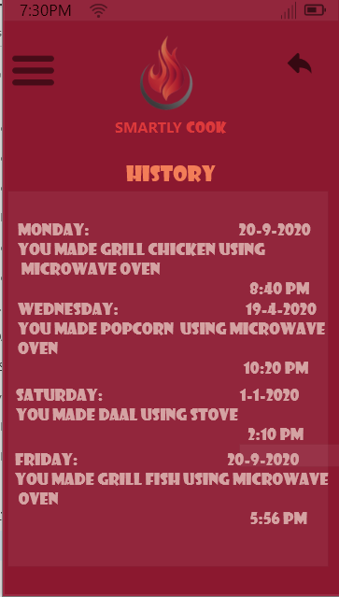

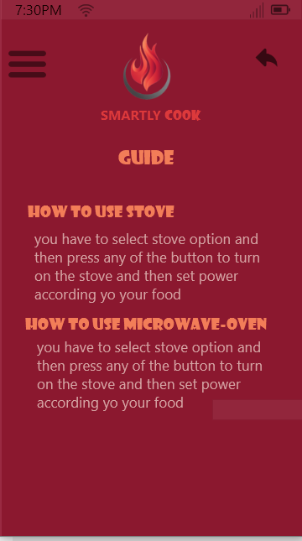

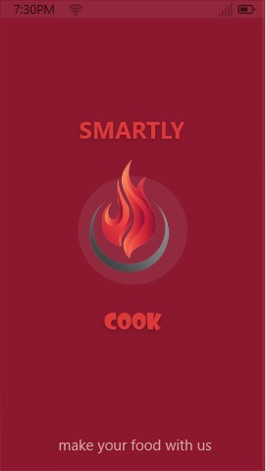

**COGNATIVE WALKTHROUGH**

**User’s Task!**

**Make A Tea**

**1 - LOGIN**

* Will user from this goal

**YES**

* Is the user sure about the command that it be will execute correctly

**YES**

* Will user understand the feedback

**YES**

* Is action is visible

**YES**

**2 - INSERT SERIAL NUMBER**

* Will user from this goal

**YES**

* Is the user sure about the command that it be will execute correctly

**YES**

* Will user understand the feedback

**YES**

* Is action is visible

**YES**

**3 - SELECT CATEGORY**

* Will user from this goal

**YES**

* Is the user sure about the command that it be will execute correctly

**YES**

* Will user understand the feedback

**YES**

* Is action is visible

**4 - CHOOSE OPTION**

* Will user from this goal

**YES**

* Is the user sure about the command that it be will execute correctly

**YES**

* Will user understand the feedback

**YES**

* Is action is visible

**YES**

**5 - STOVE SETTINGS**

* Will user from this goal

**YES**

* Is the user sure about the command that it be will execute correctly

**NO**

* Will user understand the feedback

**YES**

* Is action is visible

**NO**

**6 - CHILD LOCK**

* Will user from this goal

**YES**

* Is the user sure about the command that it be will execute correctly

**NO**

* Will user understand the feedback

**NO**

* Is action is visible

**NO**